Design Methods: Assignment 5

I want to talk about this particular time when I had the chance to design my room. Home Decor has always been something that inspires and interests me. So, when I was allowed to come up with an entire plan for the room, I was overjoyed. One significant advantage of this project was that the consumer and producer were the same people - me. I knew my taste and what I wanted my space to look like. The only person I had to please was me. This made things a lot simpler until it wasn't anymore. The problem was that I had multiple options, and I had no idea what "spoke to me". I was looking for inspiration from Pinterest (Like any other sane person), and everything looked attractive to me. If I combined all the pins I saved and designed my room accordingly, my room would be a photocopy of a circus tent. This was the point where I knew I had to take a break and walk away from the options.

After reading the article "*Tactics to spark creativity*", it all made sense to me. I knew I always performed better after taking a long nap, going for a walk, or even spending time with my family and dog. I am a morning person and tend to get drained out by evening. Surprisingly on the drive back home from work, I thought about how to solve the problems that were nagging me at work on most days. The emphasis on the green is real. I feel like green is such a pleasing color to look at. That explains why people feel more relaxed in parks and gardens. All these patterns seem so relatable after reading the article.

One of those days, I sat on my balcony, sipping a green tea, and looking at all my plants. And at that moment, it struck me that I like earthy-looking-neutral-shades more than anything. Uniformity makes me feel at ease. Creating a standard color palette became the fundamental concept of design. I began typing in the keywords on Pinterest. It was like destiny because I fell in love with the new options, which had similar themes to what I was looking for. Here are a few pictures of the finished project: -

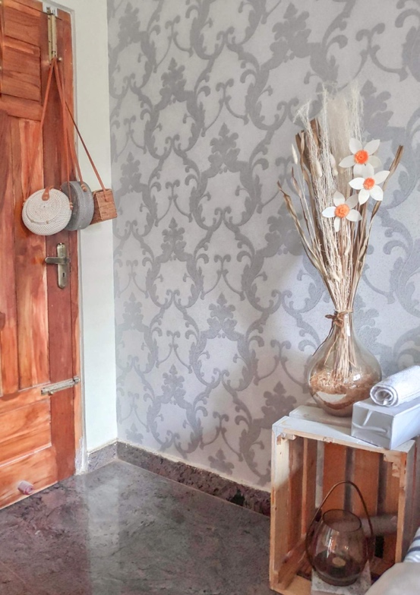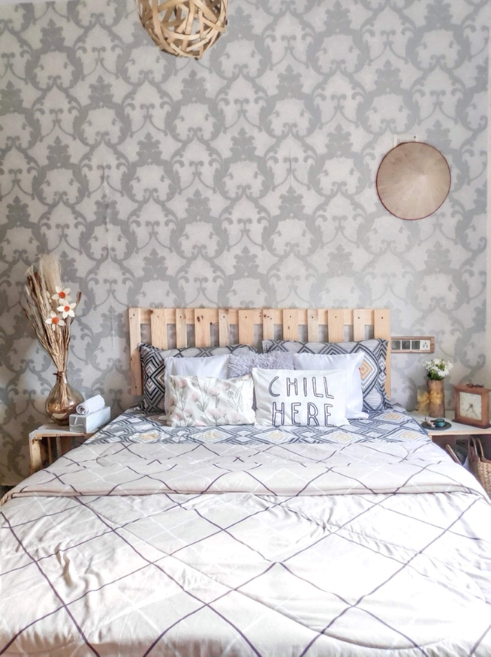

A lot of neutral-beigy tones.

Here is a picture of my balcony (I designed this too!): -

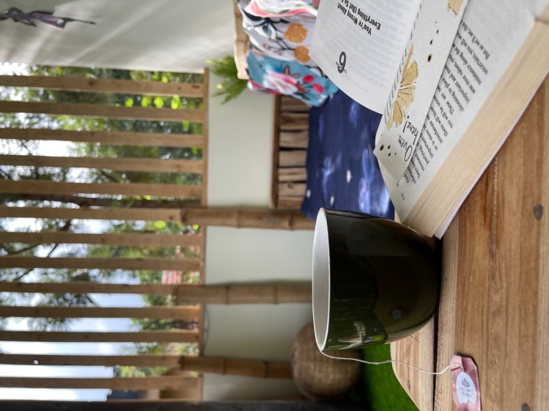

There are multiple instances when I have felt creative. As a software developer in my previous company, I had the freedom to think and design features. However, it was under a microscope, so I had to be conscious of the choices and limit my creative boundaries. The phrase "Think big" comes with its own set of rules. There are a lot of constraints when you work for a company. Not every brilliant idea seems feasible or even follows the company's guidelines. When you must produce work that is carefully examined, and your value is based on it, the pressure to come up with something new triples. The article "*The origin of good ideas – The genius of the tinkerer*" discusses how it becomes impossible to think about all the adjacent possibilities when a financial reward is associated with your idea. My office had multiple patents, and they were very private about it. I feel like opening up about a few of those accepts on a platform with other contributors from outside the company would give us completely new insight, like what happened with Nike in that article. Like most companies, mine was focused on team building, but they implemented multiple ideas to make people from different teams interact with each other. In the article "*How to be creative*", the writer talks about how diverse work groups benefit the team and how when an outsider raises an entirely new question, the whole perspective changes. It also discusses how Google placed multiple Ping-Pong tables to let people mingle. My office had a couple of foosball tables on every floor. We often bumped into people from different teams working on the front and back end. Everyone would talk about what they were currently working on. It was a great way of getting to know which way the company was heading. I think having gatherings within the company once a month and making it fun-themed would benefit any company. People from different departments must be paired together and spend the evening playing games or having drinks.

In some settings, group work is not the most ideal, and often it can be a total waste of time. But this doesn't make their need obsolete. How we conduct these brainstorming sessions reflects significantly on the outcomes. When a person is under the spotlight, it's easy to feel the pressure. Or worse, when each individual is not given a turn to speak, few remain quiet, and the others mimic this behaviour too. This topic is explained in detail in the article – "*The rise of new groupthink*". I want to illustrate this with an example: well-light party halls and discos. People are much more comfortable dancing on dimly lit dance floors in discos than at birthday parties with designated dancing areas. Because discos are low-key, the ambience makes a person feel at ease with no pressure. Similarly, having a café nature breakouts where people talk about their work freely is a big plus.

Here are a few pictures of my desk with ideas written down when my colleagues dropped by for a chat: -

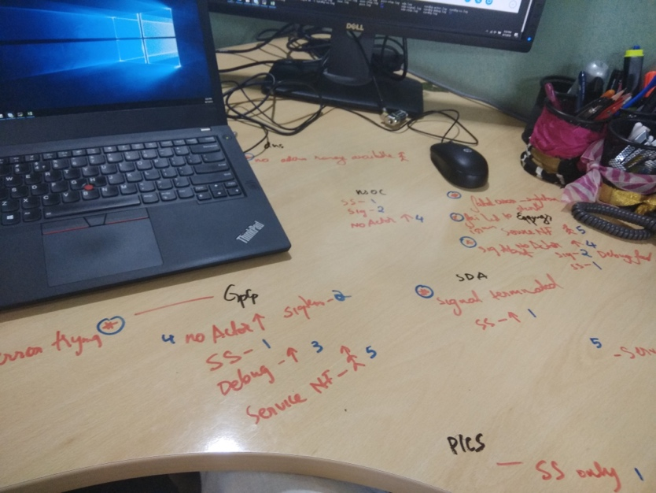

Back in college, I organized an event for all my fellow students. I had the opportunity to work with a group of volunteers to plan the entire event and develop an idea for a game. I have always been more of an individual contributor simply because I work better when I am by myself. I tried to go on multiple group-study sessions, but they never worked – conflicts of interests, nobody seemed to be listening to anyone and the worst - partial people. So, I had given up early. But this was different. I had to work with my team as a group and deliver. What happened during that process surprised me(pleasantly). I had an outline of what the game would look like, but I still had to work on the particulars. When I briefed the volunteers about the game, they came up with multiple filler options that could happen between those events. Some of these ideas were splendid. They ended up becoming a completely new section of the game itself.

It all boils down to working with people who are understanding and willing to learn. People who are open to new possibilities will be easier to coordinate with. I was fascinated by the book – "*The accidental creative*". Having a healthy lifestyle and being mindful about how you spend your free time make the difference. It is imperative to look out for energy drainers and make meaningful connections with people who challenge your intellectual instincts. Working with the volunteers felt like second nature because we had one goal: to create the best event. We executed our plan, and the event was a blast! People were genuinely having a great time. If I were to plan the entire event just by myself, I am pretty sure it wouldn't have received that kind of success.

Here are some pictures of me with my teammates trying to build a dummy cart out of cardboard:

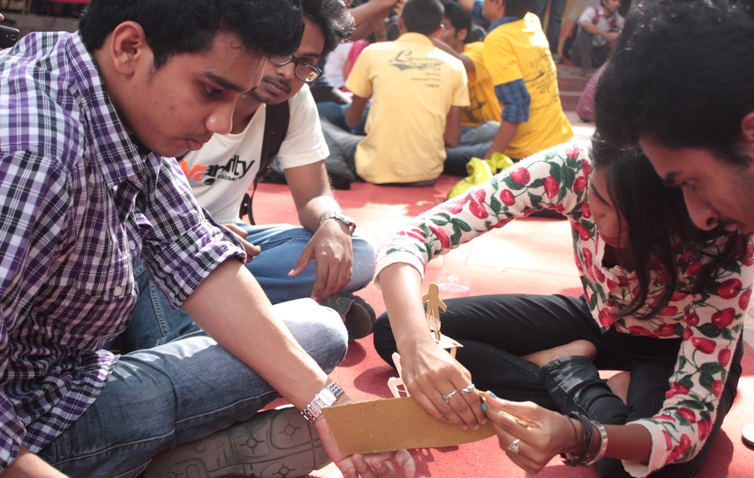

I want to return to my point that working in a group with like-minded people increases productivity. There are a few reasons I think this way, the sense of belonging and not fearing being judged boosts confidence tremendously. When you feel heard and respected, you tend to break down your walls and talk freely. The ultimate form of freedom is when a person says what's on their mind without giving it a second thought, this is particularly useful when brainstorming ideas. I agree with some parts of Alex Osborn's principles. However, I don't believe quantity is more significant than quality. It doesn't matter if the brainstorming session just produced one result, as long as this idea can be leveraged into something grander. According to Charlan Nemeth, people thrive on conflicts and produce better results when criticized. It's human to want to criticize someone's work, but if we take a step back and start considering the thought process behind the work, that's when the true magic happens. During the Intensive week, Dr Conley gave us a task. The primary focus was not to attack your neighbour's idea or find faults but to try to add on top of the concept without judgments. It was called "yes, and". This task was honestly liberating but, at the same time, somehow very difficult. Actively looking for faults has been rooted in a software developer's mindset because that's how we treat our code.

Ultimately, one should keep an open mind about what others say and learn to be flexible depending on the situation. It also helps if the person is upfront about their comfort with the group. If someone works better alone, they should inform the team beforehand so that measures can be taken accordingly. People should be more accepting of new ideas no matter how bizarre they seem at first and give them some thought.